Project Report

On

XXXXXXXXX

Project work submitted in partial fulfillment
of the requirement for the award of the degree

Master of Computer Applications

By

XXXXXXXXX

( Regd.No: XXXXXXXX )

Under the Guidance of

Mr. XXXXXXXX

(Project Coordinator, XXXXXXXXXXX)

<Paste your university emblem here>

XXXXXXX UNIVERSITY

CERTIFICATE

This is to certify that this project entitled “XXXXXXXXXXXX” is a bonafide work carried out by XXXXXXXX bearing Hall Ticket No: 02603019 in XXXXXXXXXXXXX. And submitted to XXXXX University in partial fulfillment of the requirements for the award of Master of Computer Applications.

Project Guide External Examiner Principal

Acknowledgement

ACKNOWLEDGMENT

“Task successful” makes everyone happy. But the happiness will be gold without glitter if we didn’t state the persons who have supported us to make it a success.
Success will be crowned to people who made it a reality but the people whose constant guidance and encouragement made it possible will be crowned first on the eve of success.
This acknowledgement transcends the reality of formality when we would like to express deep gratitude and respect to all those people behind the screen who guided, inspired and helped me for the completion of our project work.
I consider myself lucky enough to get such a good project. This project would add as an asset to my academic profile.
I would like to express my thankfulness to my project guide, Mr. XXXXX for his constant motivation and valuable help through the project work, and I express my gratitude to Mr. XXXXXXX, Director of XXXXXXXXX, Hyderabad, for his constant supervision, guidance and co-operation through out the project.
I also extend my thanks to my Team Members for their co-operation during my course.
Finally I would like to thanks my friends for their co-operation to complete this project.

XXXXXXX

Organization Profile
Paste Organization profile here

Contents
CONTENTS

- INTRODUCTION

INTRODUCTION TO PROJECT
EXISTING SYSTEM & ITS DISADVANTAGES
PROPOSED SYSTEM & ITS ADVANTAGES

- SYSTEM ANALYSIS

  - STUDY OF THE SYSTEM
  - INPUT & OUTPUT REPRESENTATION
  - PROCESS MODELS USED WITH JUSTIFICATION
  - SYSTEM ARCHITECTURE

- FEASIBILITY STUDY

  - TECHNICAL FEASIBILITY
  - OPERATIONAL FEASIBILITY
  - ECONOMIC FEASIBILITY

- REQUIREMENT SPECIFICATIONS

  - FUNCIONAL REQUIREMENTS
  - PERFORMANCE REQUIREMENTS
  - SOFTWARE REQUIREMENTS
  - HARDWARE REQUIREMENTS

    - INTRODUCTION TO JAVA
    - Servlets/JSP
    - JDBC
    - Oracle
    - HTML
    - JAVA SCRIPT

- SYSTEM DESIGN

  - . INTRODUCTION
  - DATA FLOW DIAGRAMS
  - UML DIAGRAMS
  - E-R DIAGRAM
  - NORMALIZATION
  - DATA DICTIONARY

- OUTPUT SCREENS

- SYSTEM TESTING
  - INTRODUCTION TO TESTING
  - TESTING STRATEGIES

- SYSTEM SECURITY

8.1 INTRODUCTION
8.2 SECURITY IN SOFTWARE

9. BIBLIOGRAPHY

Introduction
Chapter - 1

- Introduction

This Online Examination System is a software solution, which allows any industry or institute to arrange, conduct and manage examinations via an online environment. It can be done through the Internet/Intranet and/ Local Area Network environments. Some of the problems faced during manual examination systems are the delays occured in result processing, filing poses a problem, filtering of records is difficult. The chance of loss of records is high also record searching is difficult. Maintenance of the system is also very difficult and takes lot of time and effort. Online examination is one of the crucial parts for online education system. It is efficient, fast enough and reduces the large amount of material resource. An examination system is developed based on the web. This paper describes the principle of the system, presents the main functions of the system, analyzes the auto-generating test paper algorithm, and discusses the security of the system.

- Introduction
The Online Examination System is an electronic application. This framework will help the college/Institution to assess the inquiry have different alternative with one right reply. The college/Institution can direct the online examination and report the outcome in a couple time. The examination office is in charge of the creating the inquiry paper and it would be totally secure. Online Examination framework give remotely access to understudies. It assists the inspector with reducing the work of leading exam, checking answer sheets and producing result. All these work is finished by the machine. All the information is put away on the server. What’s more, customers can get to these databases and give exam. Here we utilize a customer server model. Executive offer access to instructor and understudies. Understudies who have account on the framework will have the capacity to give exam. There are two sorts of exam segment Practice and Real test. Understudies can give both tests. Right answer will be highlighted in diverse shading. Subsequent to submitting test the outcome will be created and examinations is done on the premise of result and send it to every single understudy.

- Objective
In customary framework directing exam is extremely repetitive work for analyst and educator too. The entire procedure of allocating exam and assessing their score after the test was done physically till date. Be that as it may, online examination framework is absolutely electronic framework. The framework goes for diminishing expenses connected with directing exams over a timeframe and accomplishing complete computerization of examination framework related assignments like enlistment, distribution of results, which prompts a high level of framework effectiveness. In the wake of experiencing huge numbers of reference papers at long last we are concluded that we can manufactured one examination framework that can be give easy to understand access to establish for directing exam and investigation of result.

- Methodology

  - Software Development Methodology
The methodology that is used is Prototyping. This step involves understanding the very basics product requirements especially in terms of user interface. The initial Prototyping is developed in this stage, where the very basic requirements are showcased and user interfaces are provided.

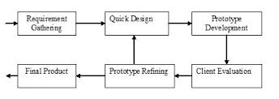

  - Requirement gathering techniques
The techniques that will be used are:-
- Research (online)
- Observation (photography studios and functions)
- Interviewing (Professional photographers, customers)

  - Tools and technology
- Software tools
- Dreamweaver
- Notepad
- Wampserver

- Hardware tools
- Hard Disk
- CPU
- Notebook

- Project Timeline

Activity | Wk 1 | Wk 2 | Wk 3 | Wk 4 | Wk 5 | Wk 6 | Wk 7 | Wk 8 | Wk 9 | Wk 10
1) Submit FYP proposal
2) Collect some information and materials required for FYP
3)Start coding for the main page, login page and registration page
4) Start Coding for user page and admin page
5) Re-Check Coding and run the system for trial
6) Write final report and prepare slides for final presentation

System Analysys
Chapter - 2

2.1 STUDY OF THE SYSTEM
To provide flexibility to the users, the interfaces have been developed that are accessible through a browser. The GUI’S at the top level have been categorized as
- Administrative user interface
- The operational or generic user interface

The ‘administrative user interface’ concentrates on the consistent information that is practically, part of the organizational activities and which needs proper authentication for the data collection. These interfaces help the administrators with all the transactional states like Data insertion, Data deletion and Date updation along with the extensive data search capabilities.
The ‘operational or generic user interface’ helps the end users of the system in transactions through the existing data and required services. The operational user interface also helps the ordinary users in managing their own information in a customized manner as per the included flexibilities
2.2 INPUT & OUTPOUT REPRESENTETION

Input design is a part of overall system design. The main objective during the input design is as given below:
- To produce a cost-effective method of input.
- To achieve the highest possible level of accuracy.
- To ensure that the input is acceptable and understood by the user.

INPUT STAGES:
The main input stages can be listed as below:
- Data recording
- Data transcription
- Data conversion
- Data verification
- Data control
- Data transmission
- Data validation
- Data correction

INPUT TYPES:
It is necessary to determine the various types of inputs. Inputs can be categorized as follows:
- External inputs, which are prime inputs for the system.
- Internal inputs, which are user communications with the system.
- Operational, which are computer department’s communications to the system?
- Interactive, which are inputs entered during a dialogue.

INPUT MEDIA:
At this stage choice has to be made about the input media. To conclude about the input media consideration has to be given to;
- Type of input
- Flexibility of format
- Speed
- Accuracy
- Verification methods
- Rejection rates
- Ease of correction
- Storage and handling requirements
- Security
- Easy to use
- Portability
Keeping in view the above description of the input types and input media, it can be said that most of the inputs are of the form of internal and interactive. As
Input data is to be the directly keyed in by the user, the keyboard can be considered to be the most suitable input device.

OUTPUT DESIGN:

In general are:
- External Outputs whose destination is outside the organization.
- Internal Outputs whose destination is with in organization and they are the User’s main interface with the computer. Outputs from computer systems are required primarily to communicate the results of processing to users. They are also used to provide a permanent copy of the results for later consultation. The various types of outputs
- Operational outputs whose use is purely with in the computer department.
- Interface outputs, which involve the user in communicating directly with the system.

OUTPUT DEFINITION

The outputs should be defined in terms of the following points:
    - Type of the output
    - Content of the output
    - Format of the output
    - Location of the output
    - Frequency of the output
    - Volume of the output
    - Sequence of the output

It is not always desirable to print or display data as it is held on a computer. It should be decided as which form of the output is the most suitable.

For Example
- Will decimal points need to be inserted
- Should leading zeros be suppressed.

OUTPUT MEDIA:
In the next stage it is to be decided that which medium is the most appropriate for the output. The main considerations when deciding about the output media are:

- The suitability for the device to the particular application.
- The need for a hard copy.
- The response time required.
- The location of the users
- The software and hardware available.

Keeping in view the above description the project is to have outputs mainly coming under the category of internal outputs. The main outputs desired according to the requirement specification are:

The outputs were needed to be generated as a hard copy and as well as queries to be viewed on the screen. Keeping in view these outputs, the format for the output is taken from the outputs, which are currently being obtained after manual processing. The standard printer is to be used as output media for hard copies.

2.3 PROCESS MODEL USED WITH JUSTIFICATION

SDLC (Spiral Model):
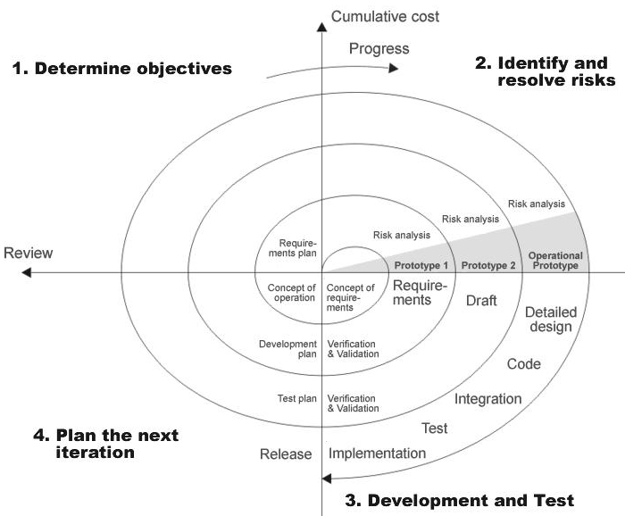

SDLC is nothing but Software Development Life Cycle. It is a standard which is used by software industry to develop good software.

Stages in SDLC:

- Requirement Gathering
- Analysis
- Designing
- Coding
- Testing
- Maintenance
Requirements Gathering stage:

The requirements gathering process takes as its input the goals identified in the high-level requirements section of the project plan. Each goal will be refined into a set of one or more requirements. These requirements define the major functions of the intended application, define
operational data areas and reference data areas, and define the initial data entities. Major functions include critical processes to be managed, as well as mission critical inputs, outputs and reports. A user class hierarchy is developed and associated with these major functions, data areas, and data entities. Each of these definitions is termed a Requirement. Requirements are identified by unique requirement identifiers and, at minimum, contain a requirement title and
textual description.
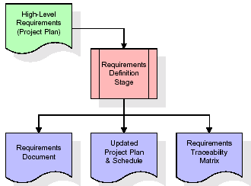

These requirements are fully described in the primary deliverables for this stage: the Requirements Document and the Requirements Traceability Matrix (RTM). The requirements document contains complete descriptions of each requirement, including diagrams and references to external documents as necessary. Note that detailed listings of database tables and fields are not included in the requirements document.
The title of each requirement is also placed into the first version of the RTM, along with the title of each goal from the project plan. The purpose of the RTM is to show that the product components developed during each stage of the software development lifecycle are formally connected to the components developed in prior stages.

In the requirements stage, the RTM consists of a list of high-level requirements, or goals, by title, with a listing of associated requirements for each goal, listed by requirement title. In this hierarchical listing, the RTM shows that each requirement developed during this stage is formally linked to a specific product goal. In this format, each requirement can be traced to a specific product goal, hence the term requirements traceability.
The outputs of the requirements definition stage include the requirements document, the RTM, and an updated project plan.
- Feasibility study is all about identification of problems in a project.
- No. of staff required to handle a project is represented as Team Formation, in this case only modules are individual tasks will be assigned to employees who are working for that project.
- Project Specifications are all about representing of various possible inputs submitting to the server and corresponding outputs along with reports maintained by administrator
Analysis Stage:

The planning stage establishes a bird's eye view of the intended software product, and uses this to establish the basic project structure, evaluate feasibility and risks associated with the project, and describe appropriate management and technical approaches.
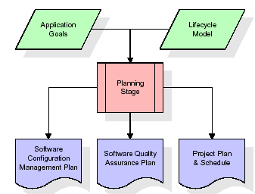

The most critical section of the project plan is a listing of high-level product requirements, also referred to as goals. All of the software product requirements to be developed during the requirements definition stage flow from one or more of these goals. The minimum information for each goal consists of a title and textual description, although additional information and references to external documents may be included. The outputs of the project planning stage are the configuration management plan, the quality assurance plan, and the project plan and schedule, with a detailed listing of scheduled activities for the upcoming Requirements stage, and high level estimates of effort for the out stages.

Designing Stage:

The design stage takes as its initial input the requirements identified in the approved requirements document. For each requirement, a set of one or more design elements will be produced as a result of interviews, workshops, and/or prototype efforts. Design elements describe the desired software features in detail, and generally include functional hierarchy diagrams, screen layout diagrams, tables of business rules, business process diagrams, pseudo code, and a complete entity-relationship diagram with a full data dictionary. These design elements are intended to describe the software in sufficient detail that skilled programmers may develop the software with minimal additional input.
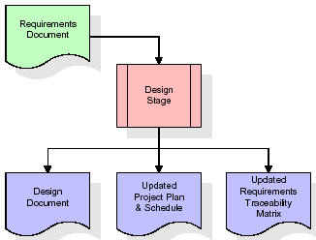

When the design document is finalized and accepted, the RTM is updated to show that each design element is formally associated with a specific requirement. The outputs of the design stage are the design document, an updated RTM, and an updated project plan.

Development (Coding) Stage:

The development stage takes as its primary input the design elements described in the approved design document. For each design element, a set of one or more software artifacts will be produced. Software artifacts include but are not limited to menus, dialogs, data management forms, data reporting formats, and specialized procedures and functions. Appropriate test cases will be developed for each set of functionally related software artifacts, and an online help system will be developed to guide users in their interactions with the software.
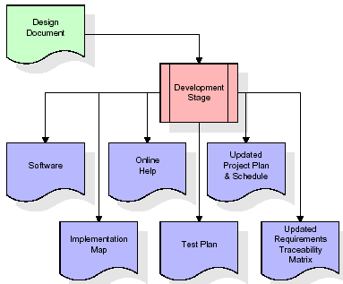

The RTM will be updated to show that each developed artifact is linked to a specific design element, and that each developed artifact has one or more corresponding test case items. At this point, the RTM is in its final configuration. The outputs of the development stage include a fully functional set of software that satisfies the requirements and design elements previously documented, an online help system that describes the operation of the software, an implementation map that identifies the primary code entry points for all major system functions, a test plan that describes the test cases to be used to validate the correctness and completeness of the software, an updated RTM, and an updated project plan.

Integration & Test Stage:

During the integration and test stage, the software artifacts, online help, and test data are migrated from the development environment to a separate test environment. At this point, all test cases are run to verify the correctness and completeness of the software. Successful execution of the test suite confirms a robust and complete migration capability. During this stage, reference data is finalized for production use and production users are identified and linked to their appropriate roles. The final reference data (or links to reference data source files) and production user list are compiled into the Production Initiation Plan.
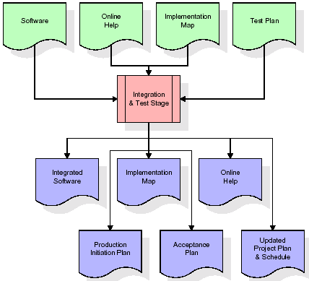

The outputs of the integration and test stage include an integrated set of software, an online help system, an implementation map, a production initiation plan that describes reference data and production users, an acceptance plan which contains the final suite of test cases, and an updated project plan.

- Installation & Acceptance Test:

During the installation and acceptance stage, the software artifacts, online help, and initial production data are loaded onto the production server. At this point, all test cases are run to verify the correctness and completeness of the software. Successful execution of the test suite is a prerequisite to acceptance of the software by the customer.
After customer personnel have verified that the initial production data load is correct and the test suite has been executed with satisfactory results, the customer formally accepts the delivery of the software.
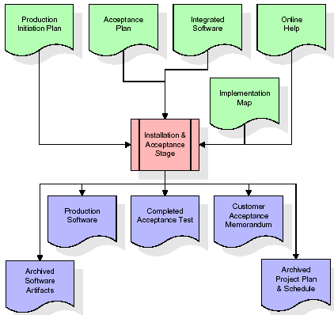
The primary outputs of the installation and acceptance stage include a production application, a completed acceptance test suite, and a memorandum of customer acceptance of the software. Finally, the PDR enters the last of the actual labor data into the project schedule and locks the project as a permanent project record. At this point the PDR "locks" the project by archiving all software items, the implementation map, the source code, and the documentation for future reference.

Maintenance:

Outer rectangle represents maintenance of a project, Maintenance team will start with requirement study, understanding of documentation later employees will be assigned work and they will under go training on that particular assigned category.
For this life cycle there is no end, it will be continued so on like an umbrella (no ending point to umbrella sticks).

2.4 SYSTEM ARCHITECTURE
Architecture flow:

Below architecture diagram represents mainly flow of requests from users to database through servers. In this scenario overall system is designed in three tires separately using three layers called presentation layer, business logic layer and data link layer. This project was developed using 3-tire architecture.
Business Logic Layer
Presentation Layer
Request
Response
Data Link
Layer
Data Base

FEASIBILITY STUDY
Chapter -3

Feasibility Study:

Preliminary investigation examines project feasibility; the likelihood the system will be useful to the organization. The main objective of the feasibility study is to test the Technical, Operational and Economical feasibility for adding new modules and debugging old running system. All systems are feasible if they are given unlimited resources and infinite time. There are aspects in the feasibility study portion of the preliminary investigation:
- Technical Feasibility
- Operation Feasibility
Economical Feasibility

3.1 TECHNICAL FEASIBILITY

The technical issue usually raised during the feasibility stage of the investigation includes the following:
- Does the necessary technology exist to do what is suggested?
- Do the proposed equipments have the technical capacity to hold the data required to use the new system?
- Will the proposed system provide adequate response to inquiries, regardless of the number or location of users?
- Can the system be upgraded if developed?
Are there technical guarantees of accuracy, reliability, ease of access and data security?

3.2 OPERATIONAL FEASIBILITY

OPERATIONAL FEASIBILITY

User-friendly
Customer will use the forms for their various transactions i.e. for adding new routes, viewing the routes details. Also the Customer wants the reports to view the various transactions based on the constraints. Theses forms and reports are generated as user-friendly to the Client.

Reliability
The package wills pick-up current transactions on line. Regarding the old transactions, User will enter them in to the system.
Security
The web server and database server should be protected from hacking, virus etc
Portability
The application will be developed using standard open source software (Except Oracle) like Java, tomcat web server, Internet Explorer Browser etc these software will work both on Windows and Linux o/s. Hence portability problems will not arise.
Availability

This software will be available always.

Maintainability

The system called the ewheelz uses the 2-tier architecture. The 1st tier is the GUI, which is said to be front-end and the 2nd tier is the database, which uses My-Sql, which is the back-end.
The front-end can be run on different systems (clients). The database will be running at the server. Users access these forms by using the user-ids and the passwords.

3.3 ECONOMIC FEASILITY

The computerized system takes care of the present existing system’s data flow and procedures completely and should generate all the reports of the manual system besides a host of other management reports.
It should be built as a web based application with separate web server and database server. This is required as the activities are spread through out the organization customer wants a centralized database. Further some of the linked transactions take place in different locations.
Open source software like TOMCAT, JAVA, Mysql and Linux is used to minimize the cost for the Customer.

REQUIREMENTS SPECIFICATION
Chapter -4

4.1 FUNCTIONAL REQUIREMENTS SPECIFICATION

This application consists following modules.
- Administrator module
- Travels module
- Routes module
- Reservations module
- Testimonials module.
1. Administrator module:
This module provides administrator related functionality. Administrator manages all information and has access rights to add, delete, edit and view the data related to places, travels, routes, bookings, restaurants etc.
2. Travels module:
This module provides the details of various travel agencies. A user can select the appropriate agency depending on convenience and accessibility.
3. Routes module:
This module provides information related to various routes connecting sources and destinations. For each route, information such as source, destination, fare, reservation details, pick up points etc are provides. Only administrator can add , delete, edit and manage the data. Users can only view the information.
4. Reservations module:
This module provides functionalities that allow a user to book tickets or cancel previously booked tickets. The module maintains the details of all reservations made so far and allows administrator to either confirm or reject the bookings.
5. Testimonials module:
Users of this application can post their opinions, complaints and suggestions regarding this portal and services to the administrator. Accordingly, the administrator can take various steps to act on the complaints and suggestions.

4.2 PERFORMANCE REQUIREMENTS

Performance is measured in terms of the output provided by the application. Requirement specification plays an important part in the analysis of a system. Only when the requirement specifications are properly given, it is possible to design a system, which will fit into required environment. It rests largely with the users of the existing system to give the requirement specifications because they are the people who finally use the system. This is because the requirements have to be known during the initial stages so that the system can be designed according to those requirements. It is very difficult to change the system once it has been designed and on the other hand designing a system, which does not cater to the requirements of the user, is of no use.
The requirement specification for any system can be broadly stated as given below:
- The system should be able to interface with the existing system
- The system should be accurate
- The system should be better than the existing system
The existing system is completely dependent on the user to perform all the duties.

4.3 SOFTWARE REQUIREMENTS:

Operating System : Windows
Technology : PHP
Web Technologies : Html, JavaScript, CSS
IDE : Netbeans, xampserver
Web Server : Tomcat
Database : MySql5.0
Java Version : J2SDK1.5

4.4 HARDWARE REQUIREMENTS:
Hardware : Pentium
RAM : 1GB
Additional Tools:

HTML Designing : Dream weaver Tool
Server : Xampserver
4.4.1. INTRODUCTION TO JAVA

Functional Requirements:
Functional requirements are associated with specific functions, tasks or behaviours the system must support. The functional requirements address the quality characteristic of functionality while the other quality characteristics are concerned with various kinds of non-functional requirements. Because non-functional requirements tend to be stated in terms of constraints on the results of tasks which are given as functional requirements (e.g., constraints on the speed or efficiency of a given task), a task-based functional requirements statement is a useful skeleton upon which to construct a complete requirements statement. That is the approach taken in this work. It can be helpful to think of non-functional requirements as adverbially related to tasks or functional requirements:
Modules:
The system is proposed to have the following modules along with functional requirements.
1.Compose Mail.
2.Sent Mail.
3.Received Mail.
4..Update Profile

Non-Functional Requirement
Non-functional requirements are requirements that specify criteria that can be used to judge the operation of a system, rather than specific behaviors. This should be contrasted with functional requirements that specify specific behavior or functions. In general, functional requirements define what a system is supposed to do whereas non-functional requirements define how a system is supposed to be. Non-functional requirements are often called qualities of a system. Other terms for non-functional requirements are "constraints", "quality attributes", "quality goals" and "quality of service requirements". Qualities, aka. Non-functional requirements can be divided into two main categories.
  - Execution qualities, such as security and usability, are observable at run time.
  - Evolution qualities, such as testability, maintainability, extensibility and scalability, are embodied in the static structure of the software system.
Scalability:
The network-deployment cost for scaling up these systems must be manageable merely having the technology to provide a user service is not sufficient. The service-provider involvement requires that different infrastructure services be available. This information helps service providers to determine where to invest next. The data-collection facility is that service want to integrate into their service and system.
Interoperability:
It is important that the interface is simple and intuitive Instead of making products and services ever more sophisticated, they must be made intuitive, simple, and useful in solving problems.
Reliability:
In order to be more reliable Join SIP is used. It enhances the performance as well as the reliability of the system and communicate with more number of people at a time. It is imperative that the service reaches thousands of people, and that it is absolutely reliable.

Portability:
In order to be more portable we use Application server and even the voice server is independent of the platform.

Extensibility:
The application should be widely extensible, where we can include many services like fax can be added in to server. Also many call routing mechanism can be included.
Efficiency:
The system should function in an efficient manner with proper acknowledgements and responses at high speed.

PHP
PHP, one of the Web’ s most popular programming languages. According to Net craft ( www.netcraft.com ), PHP was running on more than 20 million Web servers in July 2007 ( http://www.php.net/usage.php ). At the time of writing, it ’ s the fourth most popular programming language in the world according to TIOBE ( http://www.tiobe.com/index.php/ content/paperinfo/tpci/ ), beaten only by Java, C, and C++. With the introduction of version 5.3, there’ s never been a better time to learn PHP.
PHP is a programming language for building dynamic, interactive Web sites. As a general rule, PHP programs run on a Web server, and serve Web pages to visitors on request. One of the key features of PHP is that you can embed PHP code within HTML Web pages, making it very easy for you to create dynamic content quickly.
What exactly does the phrase “ dynamic, interactive Web sites ” mean? A dynamic Web page is a page whose contents can change automatically each time the page is viewed. Contrast this with a static Web page, such as a simple HTML file, which looks the same each time it’ s displayed (at least until the page is next edited). Meanwhile, an interactive Web site is a site that responds to input from its visitors. A Web forum is a good example users can post new messages to the forum, which are then displayed on the site for all to see. Another simple example is a “ contact us ” form, where visitors interact with the page by filling out and sending a form, which is then emailed to the Webmaster.
FEATURES OF PHP:
- Simple
- Secure
- Portable
SIMPLE: It is simple for professional programmer to learn & they can use it effectively. If we already know structure oriented programming, then learning php is very easy.
SECURE: As we know many people are effected by viral infection when they download an executable file or program. Rather than, virus programs we have malicious programs that can gather private information, such as credit card number, bank account balances & passwords by searching the contents of your computers local file system.
PORTABLE: As already we have discussed about compatibility of operating system, computers, chips. In Internet the programs have to be dynamically downloaded to all the various types of platforms like windows for wamp ,linux for lamp and support all platforms using xampp.
Database Management System (DBMS):
A Database is an integrated collection of user related data stored with minimum redundancy, serves many users/applications quickly and efficiently.A database system is basically a computerized record keeping system, i.e. it is a computerized system whose overall purpose is to maintain information and make that information available on demand.
DBMS is a collection of inter-related data and set of programs that allow several users to access and manipulate data. Its main purpose is to provide users with an abstract view of the data, i.e. the system hides certain details of how the data is stored and maintained.
Database Management System is divided into 4 main components
- Database.
- Hardware.
- Software.
- User.
Database: It consists of collection of persistent data that is used by the application system.
Hardware: The processor(s) and associated main memory that are used to support the execution of database system software..
Software: The layer between the physical database and the users that handles all requests from the user for access to the database.
User: There are three types of users
- Application Programmers
- End User
- Database Administrator (DBA)

TYPES OF DBMS
There are four major categories of DBMS data models.
- Hierarchical
- Network
- Inverted
- Relational
RELATIONAL DATABASE MANAGEMENT SYSTEMS
Database Management System has evolved from hierarchical to network to relational models. Today, the most widely accepted database model is the relational model. The relational database management system uses only its relational capabilities to manage the information stored in the database. The relational model has three different aspects.
- Structures.
- Operation.
- Integrity rules.
Structures:
They are well-defined objects that store the data of a database structure and the data contained within them can be manipulated by operations.

Operations:
They are clearly defined actions that allow users to manipulate the data and structures of a database. The operations on a database must adhere to a predefined set of integrity rules.
ARCHITECTURE:
Client-Server Architecture Figure shows a typical PHP/MySQL client-server architecture along with the development platform used to build and test it.
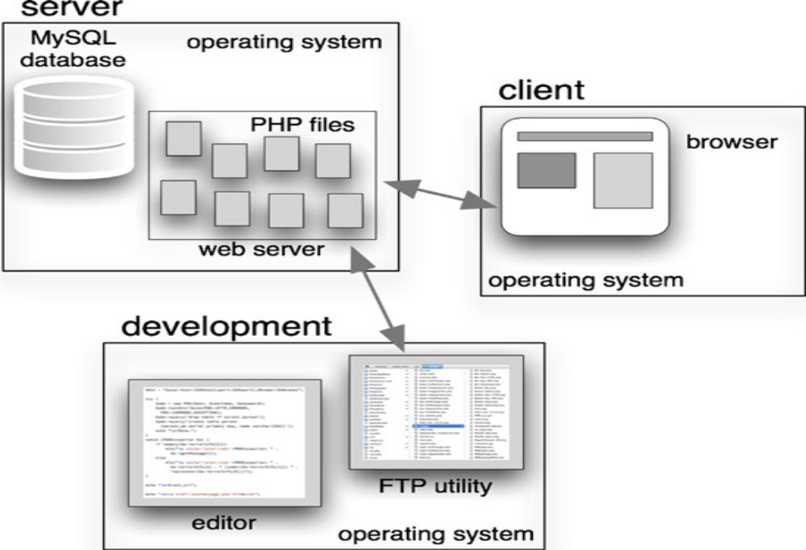
Two processes (or tasks) are of concern on the server: the database (MySQL, for us) and the web server (usually Apache or Microsoft IIS). The PHP processor runs under control of the web server and executes the PHP files that compose the application. The four labels in the server box correspond to the elements of the so-called LAMP stack: operating system (Linux), web server (Apache), database (MySQL), and language (PHP). As I’ll explain, the first doesn’t have to be Linux and the second doesn’t have to be Apache. Generally, the last two don’t have to be MySQL and PHP, but they are in this book, since that’s our focus. There are usually lots of applications running on the client, but only the browser that’s connected to the web server running the PHP application is of concern to us. Since you’re a developer, you also care about the development platform, which consists of two essential applications, at least: an editor that can create and modify PHP files and a transfer utility that can copy those files to the web server, typically an FTP (File Transfer Protocol) or SFTP (Secure File Transfer Protocol) utility, sometimes built into the editor. It’s convenient to reproduce the whole server platform on the development system so the PHP files can be accessed directly by the editor, and so you can run the application locally. To do this, it’s necessary to install a server platform on the development computer and then to open up a browser on that computer to interface with the application. Fig illustrates this process. When the application is ready to deploy, an FTP utility copies the PHP files to the remote server, as figure shows
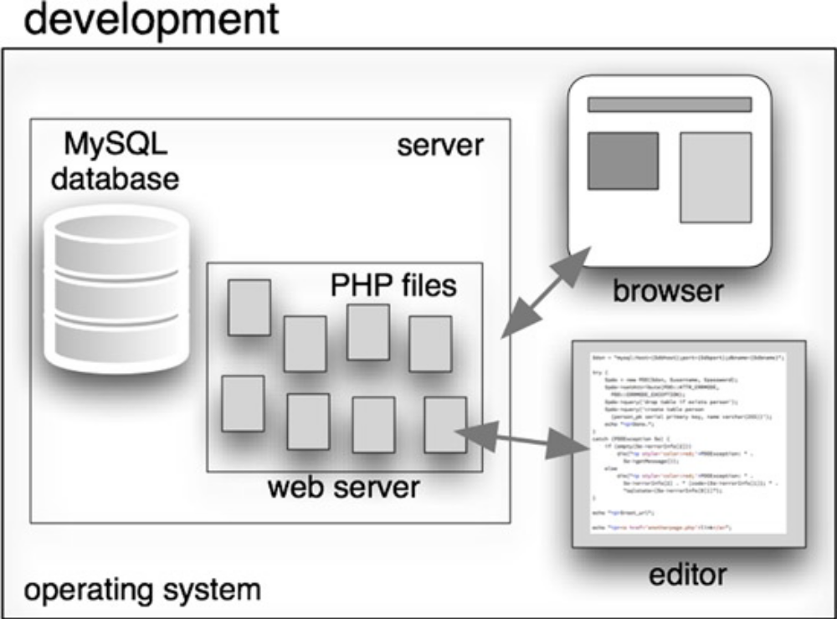
Client-Server Architecture
The server platform runs on an operating system, naturally, and on that runs the web server and the database system,MySQL. For us, the web server is programmed in PHP, and I’ll give my reasons why that’s almost always my choice, and that of lots of other people, too.
The LAMP Stack “LAMP” is a clever term for the Linux-Apache-MySQL-PHP stack, but it’s not strictly speaking a stack, because, while the web server certainly runs under the operating system, and PHP runs on the web server, the database runs directly on the operating system, independently of the web server. (Two other popular languages also begin with the letter: PERL and Python, so sometimes the P in LAMP refers to one of them.)
I have another quibble with the term “LAMP”: In practice it doesn’t make much difference what form of UNIX the operating system (OS) is—BSD and Solaris behave like Linux as far as I’m concerned as an application developer, although there are significant differences in how those systems are administered, purchased, and deployed. Windows is a commonly used server OS, too, although that choice will affect your application somewhat. Finally, while Apache runs over 60% of web sites according to w3techs.com, that still leaves the other 40%, mostly split between Microsoft’s IIS and Nginx. As with the operating system, your coding won’t be much affected, but some matters related to how the application is set up will be,
All of my examples will be for UNIX-like operating systems and Apache, and I’ll make sure I’m clear about that when it matters. So, in essence, it’s the MP part of LAMP that we care about, with P standing for PHP. Some 99% of everything in Server Operating System
According to w3techs.com, 65% of web sites run on some form of UNIX and the other 35% run on Windows. There’s really nothing else out there. (They list Mac OS separately, but it’s UNIX as far as PHP/MySQL development is concerned.)
There are four areas of Windows differences at the PHP level.
1. Path and file name differences.
2. Different line endings in text files.
3. API (application program interface) differences that affect a few PHP functions. They’re
clearly noted in the PHP documentation.
4. Command lines executed from a PHP program or directly from the shell or command
processor.
The chief path and file name differences are as follows:
Windows accepts forward slashes in paths in most PHP functions, but you might get a backslash in a path supplied by a user interactively or when you read one from a file. I usually convert backslashes to forward ones whenever I input a path on Windows. Native However, both formats are common on both systems, so this isn’t really a I’ve dealt with Mac OS and Windows differences a lot in my native applications that run on those systems, but never in my PHP/MySQL applications, because I’ve managed to avoid ever running on a Windows server. Your life may not be so simple, however.
If you get commercial web hosting from one of the numerous commercial shared-hosting companies, they’re almost always going to use Linux or BSD, with Windows sometimes being an extra-cost option. Stick with the cheaper Linux or BSD hosting.
Web Server You’ll almost always use Apache as the web server on systems and IIS on Window systems, although Apache also runs on Windows.
Apache configuration is hard to learn, but there are two saving graces for PHP/MySQL programmers. You rarely have to do much with Apache directly, aside from occasionally editing an.htaccess file to establish options for a directory.Apache is so widely used that if you Google whatever issue you’re wrestling with, you’ll usually Usability issues aside, Apache is efficient, reliable, cheap, well-documented, and ubiquitous, so it’s my web server of choice, by a wide margin. Your primary interface with Apache is with the file system that it uses. Every web site has a document root on the server, and your PHP files need to go under that root directory, or in a subdirectory of it.
If I copy the file login.php to that directory with an FTP utility, I can run that PHP program from a browser by requesting the URL. I usually run lots of applications on my web site, so I put them in subdirectories under the document root, and then direct users to a URL with a path after the domain name. For example, my site Classic Cameras is located e-mail, and my customer doesn’t really care about the cosmetics of the URL.
Database System There are lots of SQL database systems out there for web applications, and I’ve used all the major ones, including Microsoft SQL Server, Oracle, IBM DB2, PostgreSQL, and, of course, MySQL. The first three are excellent commercial systems. PostgreSQL is an open source system, with origins much older than MySQL, but it’s less widely used than MySQL, although many hosting companies offer it as an option.
In the past, MySQL supported such a limited form of SQL that it was annoying to use for a database professional spoiled by a more complete system like Oracle or PostgreSQL. But recent versions have changed that, and I now find that it has everything I want except for check conditions. My reason for preferring MySQL is simply that I find life easier if I use just one set of platform technologies, and because MySQL is always there and works extremely well, it’s always my first choice.
Sun Microsystems bought MySQL in 2008, and Oracle bought Sun about two years later, so now, somewhat ironically, Oracle owns MySQL. Despite some concern that Oracle might neglect MySQL development and/or support in order not to cannibalize Oracle sales, it hasn’t done so, and MySQL remains just as viable as ever. Nonetheless,
there’s some unease with that situation, so the MySQL original authors have taken the open source MySQL code and produced a compatible system called MariaDB, which aims to be binary compatible with it. As MySQL is still the version most widely supported by hosting companies and cloud servers, that’s the one I use.
Do what you can to make sure you’re using at least Version 5.5 of MySQL, as that’s the version I’m going to assume you have in this book. That’s where MySQL is as of this writing, Of course, it will be on to , and so on. If your application is new, start with the newest stable version. Very high-performance web sites don’t send SQL queries to the database, because they take too much processing time and make it difficult to cache results for reuse by other queries. applications, you want to use SQL. The performance of MySQL will be more than adequate.

Server Programming Language:

PHP is always there. I’ve never found a hosting company that didn’t offer it. Java is sometimes an extra-cost option, if it’s available at all, and Python and Ruby are often unavailable. PERL is as common as PHP, but it’s an even worse language. It’s fast. It’s so widely used that there’s lots of optimization for it, especially when used with Apache.
It has an extraordinary collection of extensions that allow it to handle most any web
application. Every web service (Amazon, Facebook, Flickr, etc.) has a PHP interface. Without supporting PHP, they know their support is incomplete. By contrast, they can get away with ignoring For these reasons, w3techs.com reports that PHP is used on almost 80% of web sites. (.NET is 20% and Java is 4%;some sites use more than one language.)
So, the answer to why PHP, since I can and have used almost every language that ever existed, is that it’s pleasant enough to use, always available, extremely well supported, and nearly always has a function to There are three other languages you’ll be using, as web application developers always use at least four languages.
The three others are
- HTML (including CSS),
- JavaScript, and
- SQL, to talk to the database.
HTML and JavaScript run in the browser; never on the server. SQL is passed to the database from your PHP program, or sometimes used directly on the database, so it’s a server language.
Design is the first step in moving from problem domain to the solution domain. Design is essentially the bridge between requirements specification and the final solution.
The goal of design process is to produce a model or representation of a system, which can be used later to build that system. The produced model is called the “Design of the System”. It is a plan for a solution for the system.

    - HTML

Hypertext Markup Language(HTML), the languages of the world wide web(WWW), allows users to produces web pages that included text, graphics and pointer to other web pages (Hyperlinks).

HTML is not a programming language but it is an application of ISO Standard 8879,SGML(Standard Generalized Markup Language),but
Specialized to hypertext and adapted to the Web. The idea behind Hypertext one point to another point. We can navigate through the information based on out interest and preference. A markup language is simply a series of items enclosed within the elements should be displayed.

Hyperlinks are underlined or emphasized works that load to other documents or some portions of the same document.

Html can be used to display any type of document on the host computer, which can be geographically at a different location. It is a versatile language and can be used on any platform or desktop

HTML provides tags(special codes) to make the document look attractive.

HTML provides are not case-sensitive. Using graphics,fonts,different sizes, color, etc.. can enhance the presentation of the document. Anything
That is not a tag is part of the document it self.

Basic Html Tags:
<!-- --> Specific Comments.
<A>………</A> Creates Hypertext links.
<B>………</B> Creates hypertext links.
<Big>……..</Big> Formats text in large-font
<Body>…….</Body> contains all tags and text in the Html-document
<Center>……</Center> Creates Text
<DD>………..</DD> Definition of a term.
<TABLE>……</TABLE> creates table
<Td>………..</Td> indicates table data in a table.
<Tr>………..</Tr> designates a table row
<Th>……….</Th> creates a heading in a table.

A D V A N T A G E S:-

  - A HTML document is small and hence easy to send over the net.It is small because it does not include formatted information.
  - HTML is platform independent
HTML tags are not case-sensitive.

    - JAVA SCRIPT

The Java Script Language
JavaScript is a compact , object-based scripting language for developing client and server internet applications. Netscape Navigator 2.0 interprets JavaScript statements embedded directly in an HTML page. and Livewire enables you to create server-based applications similar to common gateway interface(cgi) programs.

In a client application for Navigator, JavaScript statements embedded in an HTML Page can recognize and respond to user events such as mouse clicks form
Input, and page navigation.

For example, you can write a JavaScript function to verify that users enter valid information into a form requesting a telephone number or zip code . Without any network transmission, an Html page with embedded Java Script can interpret the entered text and alert the user with a message dialog if the input is invalid or you can use JavaScript to perform an action (such as play an audio file, execute an applet, or communicate with a plug-in) in response to the user opening or exiting a page.

SYSTEM DESIGN
Chapter - 5

5.1 INTRODUCTION
Systems design
Introduction: Systems design is the process or art of defining the architecture,
components, modules, interfaces, and data for a system to satisfy specified requirements. One
could see it as the application of systems theory to product development. There is some
overlap and synergy with the disciplines of systems analysis, systems architecture and
systems engineering.

5.3 UML DIAGRAMS

Unified Modeling Language:

The Unified Modeling Language allows the software engineer to express an analysis model using the modeling notation that is governed by a set of syntactic semantic and pragmatic rules.

A UML system is represented using five different views that describe the system from distinctly different perspective. Each view is defined by a set of diagram, which is as follows.
  - User Model View
    - This view represents the system from the users perspective.
    - The analysis representation describes a usage scenario from the end-users perspective.

  - Structural model view
    - In this model the data and functionality are arrived from inside the system.
    - This model view models the static structures.

- Behavioral Model View
It represents the dynamic of behavioral as parts of the system, depicting the interactions of collection between various structural elements described in the user model and structural model view.

- Implementation Model View
In this the structural and behavioral as parts of the system are represented as they are to be built.

- Environmental Model View

In this the structural and behavioral aspects of the environment in which the system is to be implemented are represented.

UML is specifically constructed through two different domains they are:
- UML Analysis modeling, this focuses on the user model and structural model views of the system.
- UML design modeling, which focuses on the behavioral modeling, implementation modeling and environmental model views.

Use case Diagrams represent the functionality of the system from a user’s point of view. Use cases are used during requirements elicitation and analysis to represent the functionality of the system. Use cases focus on the behavior of the system from external point of view.

Actors are external entities that interact with the system. Examples of actors include users like administrator, bank customer …etc., or another system like central database.

UML DIAGRAMS

UsE CASE DIAGRAM :

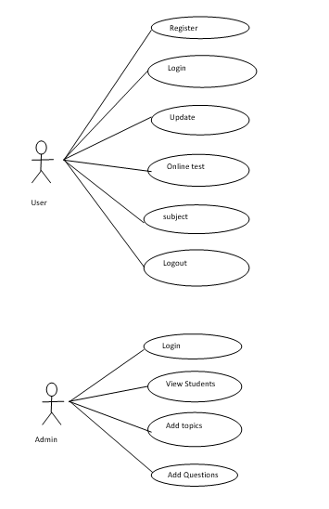

Sequence diagram:

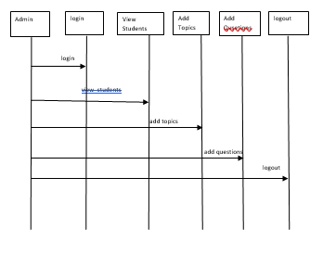
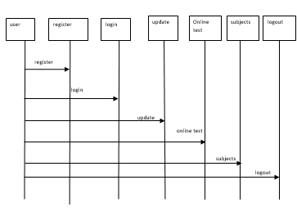

Collabration Diagram:

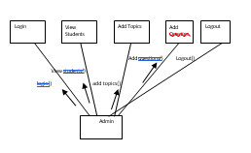
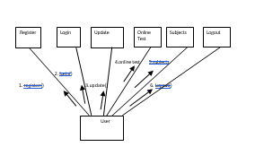

Activity Diagram:

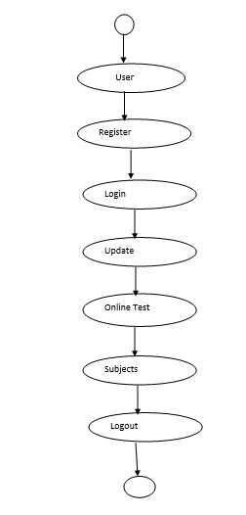
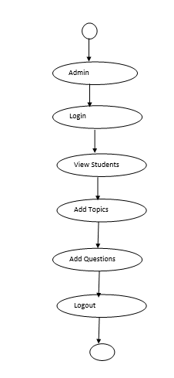

ER Diagram:

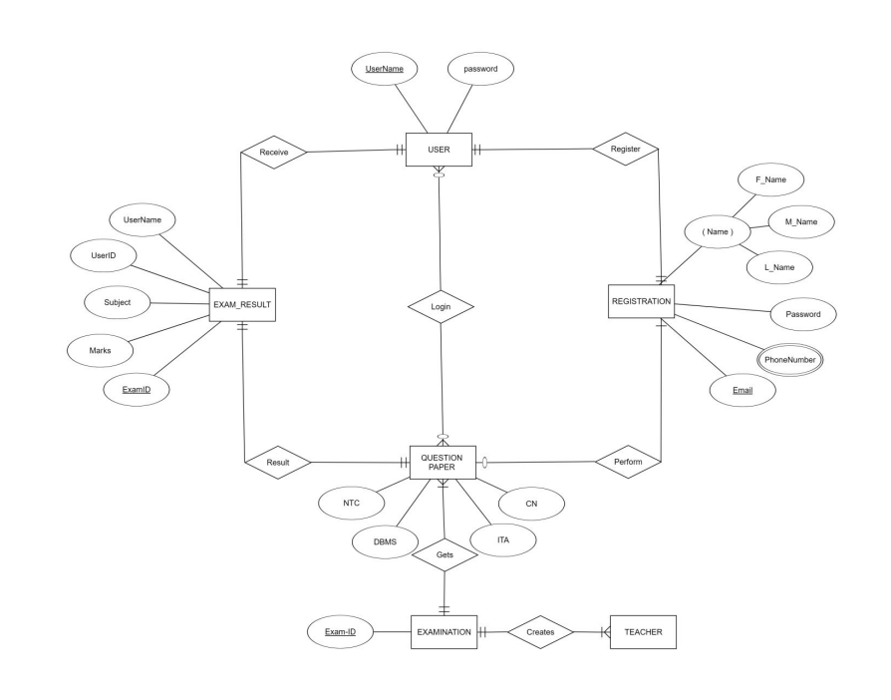

5.5. NORMALIZATION

A Database is a collection of interrelated data stored with a minimum of redundancy to serve many applications. The database design is used to group data into a number of tables and minimizes the artificiality embedded in using separate files. The tables are organized to:

- Reduced duplication of data.
- Simplify functions like adding, deleting, modifying data etc..,
- Retrieving data
- Clarity and ease of use
- More information at low cost

Normalization

Normalization is built around the concept of normal forms. A relation is said to be in a particular normal form if it satisfies a certain specified set of constraints on the kind of functional dependencies that could be associated with the relation. The normal forms are used to ensure that various types of anomalies and inconsistencies are not introduced into the database.

First Normal Form:

A relation R is in first normal form if and only if all underlying domains contained atomic values only.

Second Normal Form:

A relation R is said to be in second normal form if and only if it is in first normal form and every non-key attribute is fully dependent on the primary key.

Third Normal Form:

A relation R is said to be in third normal form if and only if it is in second normal form and every non key attribute is non transitively depend on the primary key.

5.6. DATA DICTI0NARY
/*
SQLyog Community Edition- MySQL GUI v7.15
MySQL - 5.5.29 : Database - project1
*********************************************************************
*/
/*!40101 SET NAMES utf8 */;

/*!40101 SET SQL_MODE=''*/;

/*!40014 SET @OLD_FOREIGN_KEY_CHECKS=@@FOREIGN_KEY_CHECKS, FOREIGN_KEY_CHECKS=0 */;
/*!40101 SET @OLD_SQL_MODE=@@SQL_MODE, SQL_MODE='NO_AUTO_VALUE_ON_ZERO' */;

CREATE DATABASE /*!32312 IF NOT EXISTS*/`project1` /*!40100 DEFAULT CHARACTER SET latin1 */;

USE `project1`;

--
-- Database: `project1`
--

-- --------------------------------------------------------

--
-- Table structure for table `admin`
--

CREATE TABLE `admin` (
`email` varchar(50) NOT NULL,
`password` varchar(500) NOT NULL,
`role` varchar(10) DEFAULT 'admin'
) ENGINE=InnoDB DEFAULT CHARSET=utf8;

--
-- Dumping data for table `admin`
--

INSERT INTO `admin` (`email`, `password`, `role`) VALUES
('head@gmail.com', 'head', 'head'),
('teacher1@gmail.com', 'teacher1', 'admin'),
('teacher2@gmail.com', 'teacher2', 'admin'),
('teacher3@gmail.com', 'teacher3', 'admin');

-- --------------------------------------------------------

--
-- Table structure for table `answer`
--

CREATE TABLE `answer` (
`qid` text NOT NULL,
`ansid` text NOT NULL
) ENGINE=InnoDB DEFAULT CHARSET=utf8;

--
-- Dumping data for table `answer`
--

INSERT INTO `answer` (`qid`, `ansid`) VALUES
('55892169bf6a7', '55892169d2efc'),
('5589216a3646e', '5589216a48722'),
('558922117fcef', '5589221195248'),
('55892211e44d5', '55892211f1fa7'),
('558922894c453', '558922895ea0a'),
('558922899ccaa', '55892289aa7cf'),
('558923538f48d', '558923539a46c'),
('55892353f05c4', '55892354051be'),
('558973f4389ac', '558973f462e61'),
('558973f4c46f2', '558973f4d4abe'),
('558973f51600d', '558973f526fc5'),
('558973f55d269', '558973f57af07'),
('558973f5abb1a', '558973f5e764a'),
('5589751a63091', '5589751a81bf4'),
('5589751ad32b8', '5589751adbdbd'),
('5589751b304ef', '5589751b3b04d'),
('5589751b749c9', '5589751b9a98c'),
('5bd1a29b0514c', '5bd1a29b1c417'),
('5bd1a29b7d4b8', '5bd1a29b8ae6e');

-- --------------------------------------------------------

--
-- Table structure for table `feedback`
--

CREATE TABLE `feedback` (
`id` text NOT NULL,
`name` varchar(50) NOT NULL,
`email` varchar(50) NOT NULL,
`subject` varchar(500) NOT NULL,
`feedback` varchar(500) NOT NULL,
`date` date NOT NULL,
`time` varchar(50) NOT NULL
) ENGINE=InnoDB DEFAULT CHARSET=utf8;

-- --------------------------------------------------------

--
-- Table structure for table `history`
--

CREATE TABLE `history` (
`email` varchar(50) NOT NULL,
`eid` text NOT NULL,
`score` int(11) NOT NULL,
`level` int(11) NOT NULL,
`sahi` int(11) NOT NULL,
`wrong` int(11) NOT NULL,
`date` timestamp NOT NULL DEFAULT CURRENT_TIMESTAMP ON UPDATE CURRENT_TIMESTAMP
) ENGINE=InnoDB DEFAULT CHARSET=utf8;

-- --------------------------------------------------------

--
-- Table structure for table `options`
--

CREATE TABLE `options` (
`qid` varchar(50) NOT NULL,
`option` varchar(5000) NOT NULL,
`optionid` text NOT NULL
) ENGINE=InnoDB DEFAULT CHARSET=utf8;

--
-- Dumping data for table `options`
--

INSERT INTO `options` (`qid`, `option`, `optionid`) VALUES
('55892169bf6a7', 'usermod', '55892169d2efc'),
('55892169bf6a7', 'useradd', '55892169d2f05'),
('55892169bf6a7', 'useralter', '55892169d2f09'),
('55892169bf6a7', 'groupmod', '55892169d2f0c'),
('5589216a3646e', '751', '5589216a48713'),
('5589216a3646e', '752', '5589216a4871a'),
('5589216a3646e', '754', '5589216a4871f'),
('5589216a3646e', '755', '5589216a48722'),
('558922117fcef', 'echo', '5589221195248'),
('558922117fcef', 'print', '558922119525a'),
('558922117fcef', 'printf', '5589221195265'),
('558922117fcef', 'cout', '5589221195270'),
('55892211e44d5', 'int a', '55892211f1f97'),
('55892211e44d5', '$a', '55892211f1fa7'),
('55892211e44d5', 'long int a', '55892211f1fb4'),
('55892211e44d5', 'int a$', '55892211f1fbd'),
('558922894c453', 'cin>>a;', '558922895ea0a'),
('558922894c453', 'cin<<a;', '558922895ea26'),
('558922894c453', 'cout>>a;', '558922895ea34'),
('558922894c453', 'cout<a;', '558922895ea41'),
('558922899ccaa', 'cout', '55892289aa7cf'),
('558922899ccaa', 'cin', '55892289aa7df'),
('558922899ccaa', 'print', '55892289aa7eb'),
('558922899ccaa', 'printf', '55892289aa7f5'),
('558923538f48d', '255.0.0.0', '558923539a46c'),
('558923538f48d', '255.255.255.0', '558923539a480'),
('558923538f48d', '255.255.0.0', '558923539a48b'),
('558923538f48d', 'none of these', '558923539a495'),
('55892353f05c4', '192.168.1.100', '5589235405192'),
('55892353f05c4', '172.168.16.2', '55892354051a3'),
('55892353f05c4', '10.0.0.0.1', '55892354051b4'),
('55892353f05c4', '11.11.11.11', '55892354051be'),
('558973f4389ac', 'containing root file-system required during bootup', '558973f462e44'),
('558973f4389ac', ' Contains only scripts to be executed during bootup', '558973f462e56'),
('558973f4389ac', ' Contains root-file system and drivers required to be preloaded during bootup', '558973f462e61'),
('558973f4389ac', 'None of the above', '558973f462e6b'),
('558973f4c46f2', 'Kernel', '558973f4d4abe'),
('558973f4c46f2', 'Shell', '558973f4d4acf'),
('558973f4c46f2', 'Commands', '558973f4d4ad9'),
('558973f4c46f2', 'Script', '558973f4d4ae3'),
('558973f51600d', 'Boot Loading', '558973f526f9d'),
('558973f51600d', ' Boot Record', '558973f526fb9'),
('558973f51600d', ' Boot Strapping', '558973f526fc5'),
('558973f51600d', ' Booting', '558973f526fce'),
('558973f55d269', ' Quick boot', '558973f57aef1'),
('558973f55d269', 'Cold boot', '558973f57af07'),
('558973f55d269', ' Hot boot', '558973f57af17'),
('558973f55d269', ' Fast boot', '558973f57af27'),
('558973f5abb1a', 'bash', '558973f5e7623'),
('558973f5abb1a', ' Csh', '558973f5e7636'),
('558973f5abb1a', ' ksh', '558973f5e7640'),
('558973f5abb1a', ' sh', '558973f5e764a'),
('5589751a63091', 'q', '5589751a81bd6'),
('5589751a63091', 'wq', '5589751a81be8'),
('5589751a63091', ' both (a) and (b)', '5589751a81bf4'),
('5589751a63091', ' none of the mentioned', '5589751a81bfd'),
('5589751ad32b8', ' moves screen down one page', '5589751adbdbd'),
('5589751ad32b8', 'moves screen up one page', '5589751adbdce'),
('5589751ad32b8', 'moves screen up one line', '5589751adbdd8'),
('5589751ad32b8', ' moves screen down one line', '5589751adbde2'),
('5589751b304ef', ' yy', '5589751b3b04d'),
('5589751b304ef', 'yw', '5589751b3b05e'),
('5589751b304ef', 'yc', '5589751b3b069'),
('5589751b304ef', ' none of the mentioned', '5589751b3b073'),
('5589751b749c9', 'X', '5589751b9a98c'),
('5589751b749c9', 'x', '5589751b9a9a5'),
('5589751b749c9', 'D', '5589751b9a9b7'),
('5589751b749c9', 'd', '5589751b9a9c9'),
('5589751bd02ec', 'autoindentation is not possible in vi editor', '5589751bdadaa'),
('5bd1a29b0514c', 'left-root-right', '5bd1a29b1c417'),
('5bd1a29b0514c', 'root-left-right', '5bd1a29b1c42c'),
('5bd1a29b0514c', 'right-left-root', '5bd1a29b1c42d'),
('5bd1a29b0514c', 'none of these', '5bd1a29b1c42e'),
('5bd1a29b7d4b8', 'left-root-right', '5bd1a29b8ae62'),
('5bd1a29b7d4b8', 'root-left-right', '5bd1a29b8ae6e'),
('5bd1a29b7d4b8', 'right-left-root', '5bd1a29b8ae70'),
('5bd1a29b7d4b8', 'none of these', '5bd1a29b8ae71');

-- --------------------------------------------------------

--
-- Table structure for table `questions`
--

CREATE TABLE `questions` (
`eid` text NOT NULL,
`qid` text NOT NULL,
`qns` text NOT NULL,
`choice` int(10) NOT NULL,
`sn` int(11) NOT NULL
) ENGINE=InnoDB DEFAULT CHARSET=utf8;

--
-- Dumping data for table `questions`
--

INSERT INTO `questions` (`eid`, `qid`, `qns`, `choice`, `sn`) VALUES
('558920ff906b8', '55892169bf6a7', 'what is command for changing user information??', 4, 1),
('558920ff906b8', '5589216a3646e', 'what is permission for view only for other??', 4, 2),
('558921841f1ec', '558922117fcef', 'what is command for print in php??', 4, 1),
('558921841f1ec', '55892211e44d5', 'which is a variable of php??', 4, 2),
('5589222f16b93', '558922894c453', 'what is correct statement in c++??', 4, 1),
('5589222f16b93', '558922899ccaa', 'which command is use for print the output in c++?', 4, 2),
('558922ec03021', '558923538f48d', 'what is correct mask for A class IP???', 4, 1),
('558922ec03021', '55892353f05c4', 'which is not a private IP??', 4, 2),
('55897338a6659', '558973f4389ac', 'On Linux, initrd is a file', 4, 1),
('55897338a6659', '558973f4c46f2', 'Which is loaded into memory when system is booted?', 4, 2),
('55897338a6659', '558973f51600d', ' The process of starting up a computer is known as', 4, 3),
('55897338a6659', '558973f55d269', ' Bootstrapping is also known as', 4, 4),
('55897338a6659', '558973f5abb1a', 'The shell used for Single user mode shell is:', 4, 5),
('5589741f9ed52', '5589751a63091', ' Which command is used to close the vi editor?', 4, 1),
('5589741f9ed52', '5589751ad32b8', ' In vi editor, the key combination CTRL+f', 4, 2),
('5589741f9ed52', '5589751b304ef', ' Which vi editor command copies the current line of the file?', 4, 3),
('5589741f9ed52', '5589751b749c9', ' Which command is used to delete the character before the cursor location in vi editor?', 4, 4),
('5589741f9ed52', '5589751bd02ec', ' Which one of the following statement is true?', 4, 5),
('5bd1a1a3c5e5b', '5bd1a29b0514c', 'What is inorder?', 4, 1),
('5bd1a1a3c5e5b', '5bd1a29b7d4b8', 'what is pre order?', 4, 2);

-- --------------------------------------------------------

--
-- Table structure for table `quiz`
--

CREATE TABLE `quiz` (
`eid` text NOT NULL,
`title` varchar(100) NOT NULL,
`sahi` int(11) NOT NULL,
`wrong` int(11) NOT NULL,
`total` int(11) NOT NULL,
`time` bigint(20) NOT NULL,
`intro` text NOT NULL,
`tag` varchar(100) NOT NULL,
`date` timestamp NOT NULL DEFAULT CURRENT_TIMESTAMP ON UPDATE CURRENT_TIMESTAMP,
`email` varchar(50) DEFAULT NULL
) ENGINE=InnoDB DEFAULT CHARSET=utf8;

--
-- Dumping data for table `quiz`
--

INSERT INTO `quiz` (`eid`, `title`, `sahi`, `wrong`, `total`, `time`, `intro`, `tag`, `date`, `email`) VALUES
('558920ff906b8', 'Linux : File Managment', 2, 1, 2, 5, '', 'linux', '2018-10-20 14:47:56', 'teacher2@gmail.com'),
('558921841f1ec', 'Php Coding', 2, 1, 2, 5, '', 'PHP', '2018-10-20 14:47:04', 'teacher1@gmail.com'),
('5589222f16b93', 'C++ Coding', 2, 1, 2, 5, '', 'c++', '2018-10-20 14:47:04', 'teacher1@gmail.com'),
('558922ec03021', 'Networking', 2, 1, 2, 5, '', 'networking', '2018-10-20 14:47:04', 'teacher1@gmail.com'),
('55897338a6659', 'Linux:startup', 2, 1, 5, 10, '', 'linux', '2018-10-20 14:47:56', 'teacher2@gmail.com'),
('5589741f9ed52', 'Linux :vi Editor', 2, 1, 5, 10, '', 'linux', '2018-10-20 14:47:56', 'teacher2@gmail.com'),
('5bd1a1a3c5e5b', 'Data Structure', 1, 0, 2, 1, 'ds exam', 'ds', '2018-10-25 10:57:39', 'teacher2@gmail.com');

-- --------------------------------------------------------

--
-- Table structure for table `rank`
--

CREATE TABLE `rank` (
`email` varchar(50) NOT NULL,
`score` int(11) NOT NULL,
`time` timestamp NOT NULL DEFAULT CURRENT_TIMESTAMP ON UPDATE CURRENT_TIMESTAMP
) ENGINE=InnoDB DEFAULT CHARSET=utf8;

-- --------------------------------------------------------

--
-- Table structure for table `user`
--

CREATE TABLE `user` (
`name` varchar(50) NOT NULL,
`gender` varchar(5) NOT NULL,
`college` varchar(100) NOT NULL,
`email` varchar(50) NOT NULL,
`mob` bigint(20) NOT NULL,
`password` varchar(50) NOT NULL
) ENGINE=InnoDB DEFAULT CHARSET=utf8;

--
-- Indexes for dumped tables
--

--
-- Indexes for table `admin`
--
ALTER TABLE `admin`
ADD PRIMARY KEY (`email`);

--
-- Indexes for table `user`
--
ALTER TABLE `user`
ADD PRIMARY KEY (`email`);
COMMIT;

/*!40101 SET SQL_MODE=@OLD_SQL_MODE */;
/*!40014 SET FOREIGN_KEY_CHECKS=@OLD_FOREIGN_KEY_CHECKS */;

OUTPUT SCREENS
Chapter -6

Output
Screens

INDEX PAGE:
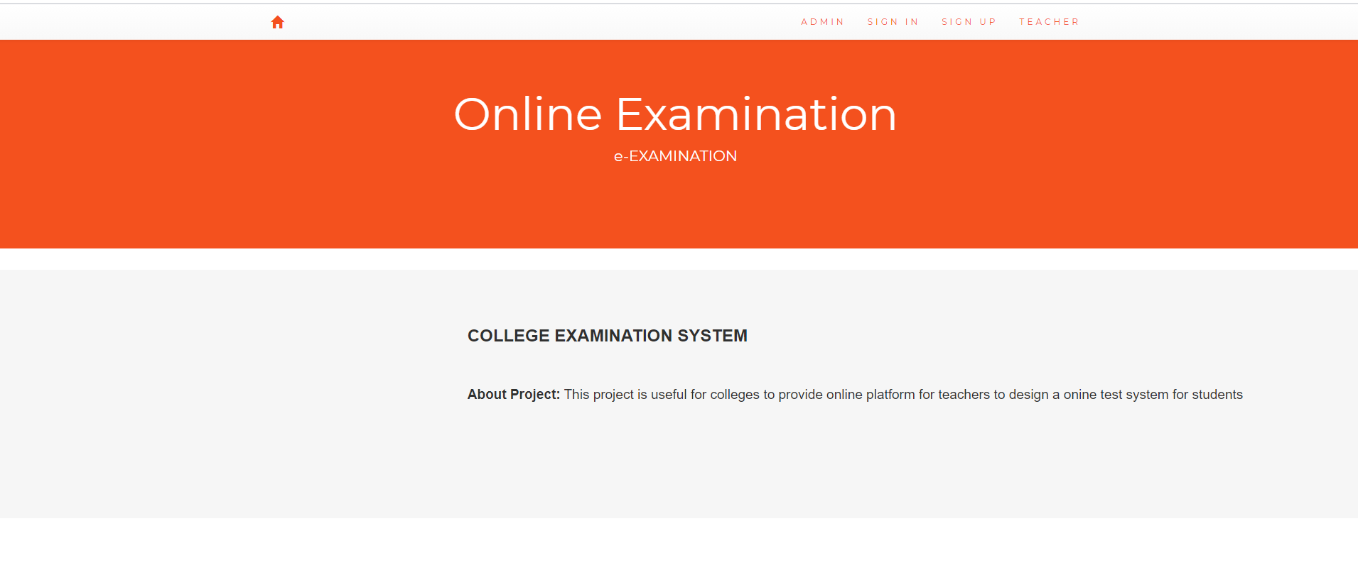

Admin login:

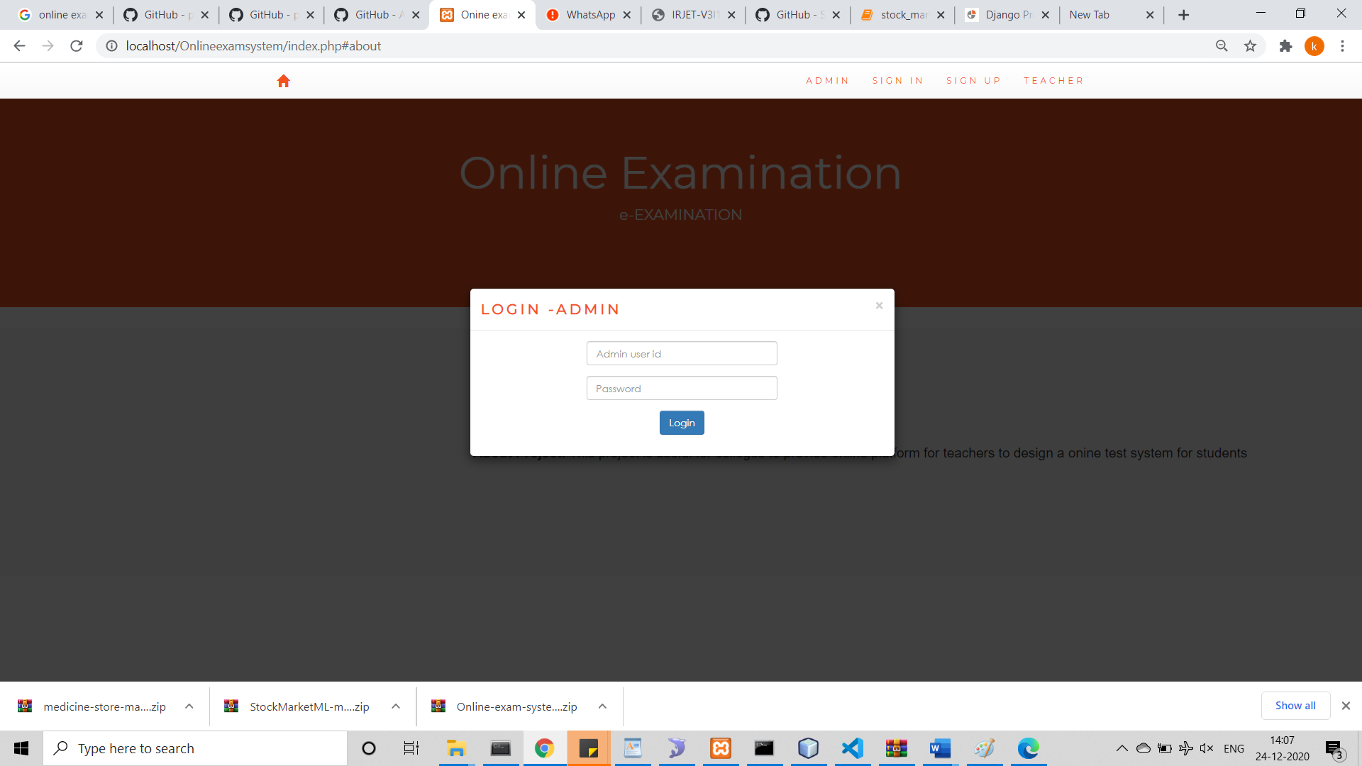

Admin main page:

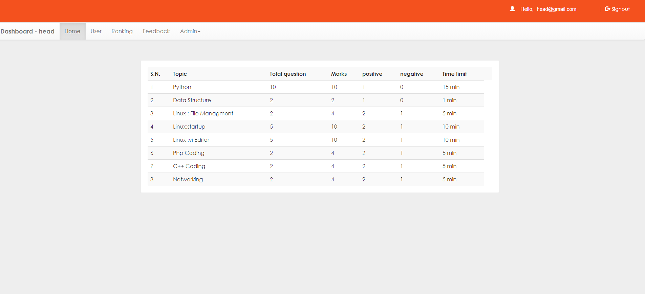

Admin view Users:

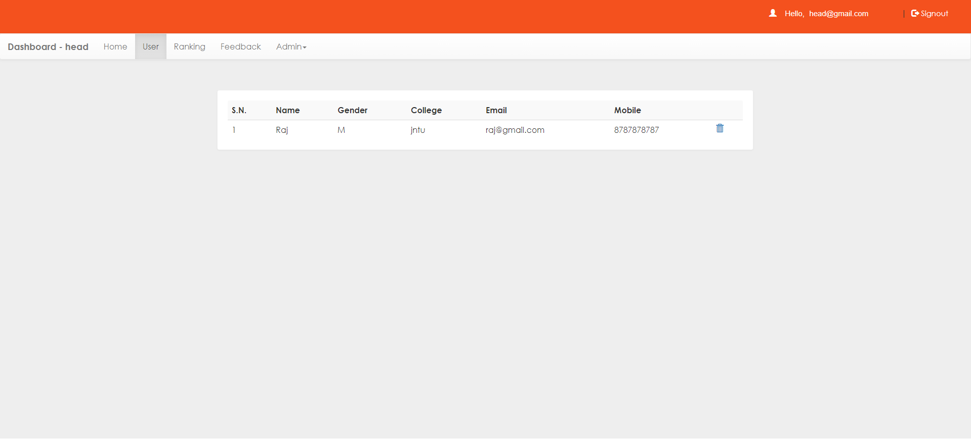

Ranking Page:

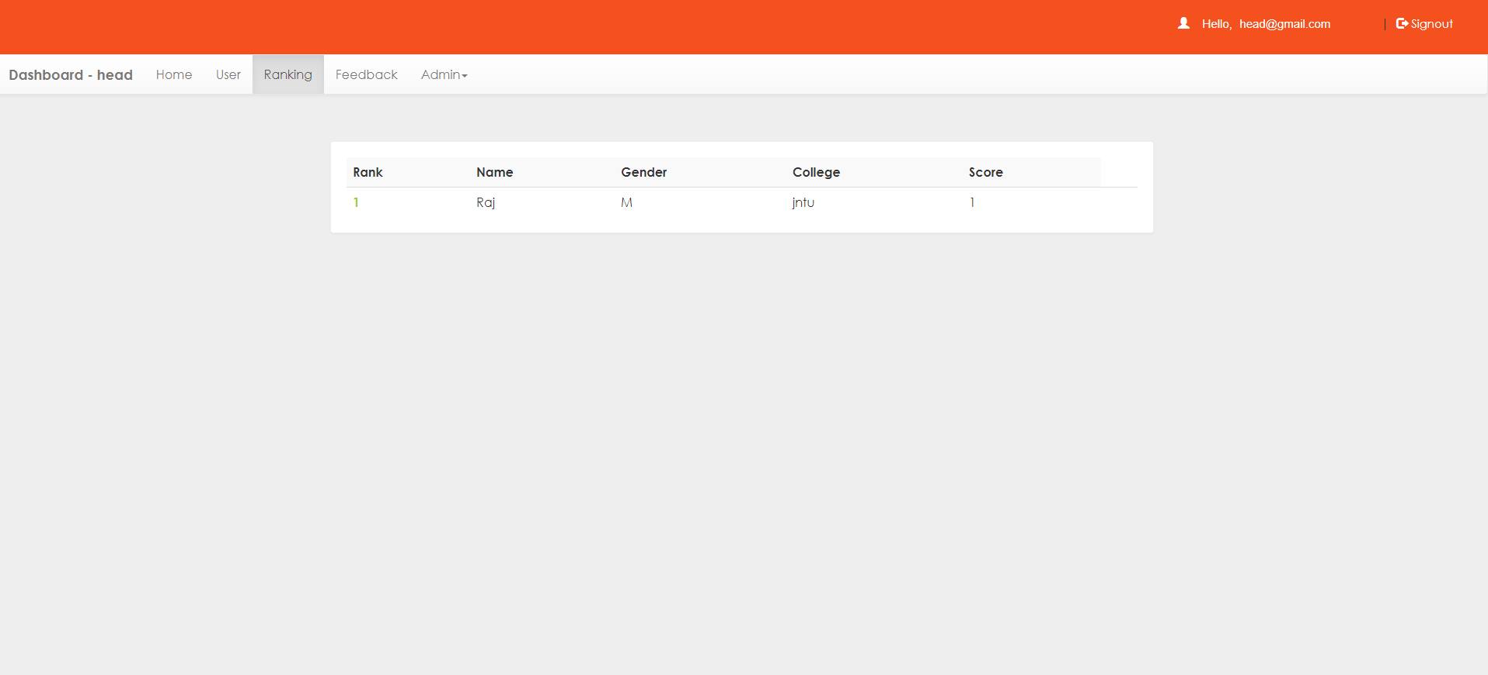

Teacher Home page:

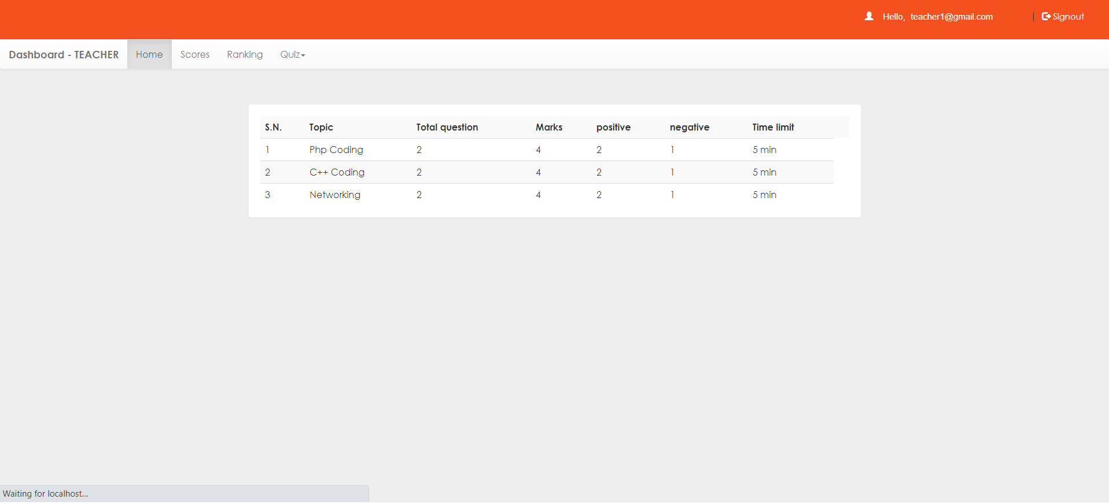

Add questions:

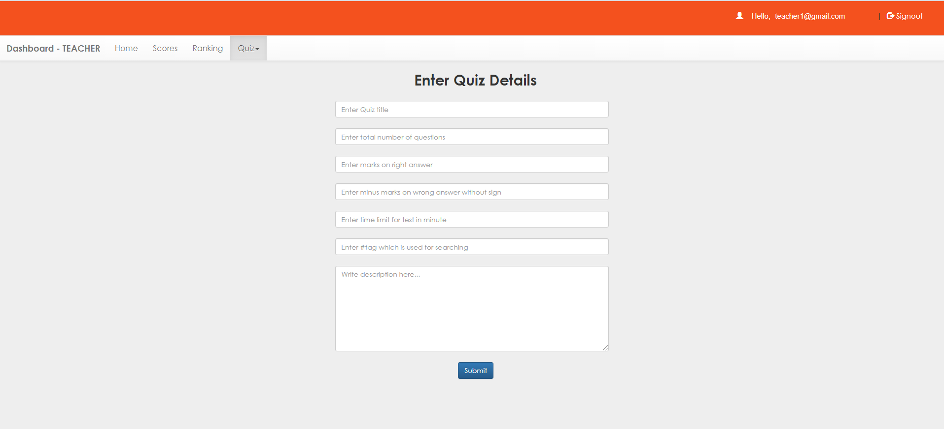

SYSTEM TESTING
Chapter -7

7.1 INTRODUCTION TO TESTING

Introduction to Testing:
Testing is a process, which reveals errors in the program. It is the major quality measure employed during software development. During software development. During testing, the program is executed with a set of test cases and the output of the program for the test cases is evaluated to determine if the program is performing as it is expected to perform.

7.2 TESTING IN STRATEGIES

In order to make sure that the system does not have errors, the different levels of testing strategies that are applied at differing phases of software development are:
Unit Testing:

Unit Testing is done on individual modules as they are completed and become executable. It is confined only to the designer's requirements.

Each module can be tested using the following two Strategies:
Black Box Testing:
In this strategy some test cases are generated as input conditions that fully execute all functional requirements for the program. This testing has been uses to find errors in the following categories:
- Incorrect or missing functions
- Interface errors
- Errors in data structure or external database access
- Performance errors
- Initialization and termination errors.
In this testing only the output is checked for correctness.
The logical flow of the data is not checked.

White Box testing:
In this the test cases are generated on the logic of each module by drawing flow graphs of that module and logical decisions are tested on all the cases. It has been uses to generate the test cases in the following cases:

- Guarantee that all independent paths have been Executed.
- Execute all logical decisions on their true and false Sides.
- Execute all loops at their boundaries and within their operational bounds
- Execute internal data structures to ensure their validity.
Integrating Testing :
Integration testing ensures that software and subsystems work together a whole. It tests the interface of all the modules to make sure that the modules behave properly when integrated together.
System Testing :
Involves in-house testing of the entire system before delivery to the user. It's aim is to satisfy the user the system meets all requirements of the client's specifications.
Acceptance Testing :

It is a pre-delivery testing in which entire system is tested at client's site on real world data to find errors.

Test Approach :
Testing can be done in two ways:

- Bottom up approach
- Top down approach
Bottom up Approach:

Testing can be performed starting from smallest and lowest level modules and proceeding one at a time. For each module in bottom up testing a short program executes the module and provides the needed data so that the module is asked to perform the way it will when embedded with in the larger system. When bottom level modules are tested attention turns to those on the next level that use the lower level ones they are tested individually and then linked with the previously examined lower level modules.
Top down approach:
This type of testing starts from upper level modules. Since the detailed activities usually performed in the lower level routines are not provided stubs are written. A stub is a module shell called by upper level module and that when reached properly will return a message to the calling module indicating that proper interaction occurred. No attempt is made to verify the correctness of the lower level module.

Validation:

The system has been tested and implemented successfully and thus ensured that all the requirements as listed in the software requirements specification are completely fulfilled. In case of erroneous input corresponding error messages are displayed

SYSTEM SECURITY
Chapter -8

8.1 INTRODUCTION

System Security:
Setting Up Authentication for Web Applications
Introduction:
To configure authentication for a Web Application, use the <login-config> element of the web.xml deployment descriptor. In this element you define the security realm containing the user credentials, the method of authentication, and the location of resources for authentication.

8.2 SECURITY IN SOFTWARE
To set up authentication for Web Applications:
- Open the web.xml deployment descriptor in a text editor or use the Administration Console. Specify the authentication method using the <auth-method> element. The available options are:
BASIC
Basic authentication uses the Web Browser to display a username/password dialog box. This username and password is authenticated against the realm.
FORM
Form-based authentication requires that you return an HTML form containing the username and password. The fields returned from the form elements must be: j_username and j_password, and the action attribute must be j_security_check. Here is an example of the HTML coding for using FORM authentication:
<form method="POST" action="j_security_check">
<input type="text" name="j_username">
<input type="password" name="j_password">
</form>
The resource used to generate the HTML form may be an HTML page, a JSP, or a servlet. You define this resource with the <form-login-page> element.

The HTTP session object is created when the login page is served. Therefore, the session.isNew() method returns FALSE when called from pages served after successful authentication.

BIBLIOGRAPHY
Chapter - 9

9. BIBLIOGRAPHY

References for the Project Development Were Taken From the following Books and Web Sites.

JAVA Technologies
JAVA Complete Reference
Java Script Programming by Yehuda Shiran
Mastering JAVA Security
JAVA2 Networking by Pistoria
JAVA Security by Scotl oaks
Head First EJB Sierra Bates
J2EE Professional by Shadab siddiqui
JAVA server pages by Larne Pekowsley
JAVA Server pages by Nick Todd

HTML
HTML Black Book by Holzner

JDBC
Java Database Programming with JDBC by Patel moss.
Software Engineering by Roger Pressman

